Epsom & Ewell F.C.
2
v
CB Hounslow United
Tuesday, 16th August 2016
Good evening and welcome to High Road for our opening home League match of the season. We welcome the players, supporters and officials of CB Hounslow United, and of course our own supporters.

Although this is their first visit to High Road, we have met once before, ten years ago next month at their old ground in Osterley for a Combined Counties League Cup tie. We understand that a new ground is close, so we wish them well on that front, as we know more than most what it is like to be without a ground.

We had suffered a pretty awful start to what was our first season in the Combined Counties League and had already dispensed with Manager Paul Pritchard so Peter Augustine was in charge for this match. And it looked like we would be in for our first win of the season as we led early in the second half through Dale Marvell but contrived to lose this match 2-1 and had to wait until November before finally getting our first win. Revenge would be nice, but we are well aware that they had a great season following promotion as Champions and will be difficult opponents.

Last time we were here we faced another first time visitor in Gravesham Borough who belied their Step Six status to take an early lead which they held until the 40th minute when Daryl Cooper-Smith equalised. Tom Neale put us ahead midway through the second half and when they were reduced to ten men, it looked all over, yet we conceded an equaliser five minutes from time! Luckily there was enough time for us to get another opportunity and after Neale had been fouled Sam Robinson tucked away the penalty and further goals in injury time from Cooper-Smith and Jordan Gallagher on his debut gave the scoreline a rather flattering look!

With the Sutton Common Rovers match put back to 8th November due to their F.A. Cup replay our next match was at Windsor three days ago, and we led there but lost to a late goal. It was not our best display but we didn’t deserve to lose either in this very even match.

On Saturday we make the visit to Faversham Town in the F.A. Cup Preliminary Round. As a Ryman South club, and a good one at that, this will be a tough match for us, but we go into the encounter with all the pressure and expectations on the hosts and you never know. Following that we are back on duty here, either for a Cup replay with Faversham Town or at home to another of the division’s new boys Abbey Rangers.

We then visit Colliers Wood United on the Friday evening and Horley Town on the August Bank Holiday morning with an 11.30 kick off.

Enjoy the game!

Rich
Please follow us on Facebook: www.facebook.com/epsomandewellfc Twitter: @EEFCOfficial and
on Instagram at: www.instagram.com/epsomandewellfc We also have a Youtube channel now!

Cover photos by Gemma Jarman

- Daryl Cooper-Smith scores our first of nine goals at Bedfont & Feltham

- Matt Farrell scores our third goal in the same match

Cherry Red Records Combined Counties League
Premier Division Table 2016/17
including Saturday 13th August | P | W | D | L | F | A | Pts | GD | H | A
Hartley Wintney | 2 | 2 | 0 | 0 | 5 | 1 | 6 | +4 | 18/3 | 10/12
Hanworth Villa | 2 | 2 | 0 | 0 | 5 | 2 | 6 | +3 | 13/12 | 14/1
Horley Town | 2 | 1 | 1 | 0 | 5 | 3 | 4 | +2 | 29/8 | 17/4
Epsom & Ewell | 2 | 1 | 0 | 1 | 10 | 4 | 3 | +6 | X | X
Camberley Town | 2 | 1 | 0 | 1 | 7 | 4 | 3 | +3 | 10/9 | 1/4
Westfield | 1 | 1 | 0 | 0 | 3 | 0 | 3 | +3 | 18/2 | tba
Guildford City | 1 | 1 | 0 | 0 | 4 | 2 | 3 | +2 | tba | 5/11
North Greenford United | 2 | 1 | 0 | 1 | 4 | 2 | 3 | +2 | 22/4 | 15/10
Chertsey Town | 1 | 1 | 0 | 0 | 2 | 0 | 3 | +2 | 17/12 | 11/2
Bedfont Sports | 1 | 1 | 0 | 0 | 3 | 2 | 3 | +1 | 19/11 | 7/2
Knaphill | 1 | 1 | 0 | 0 | 3 | 2 | 3 | +1 | 24/9 | 8/4
Windsor | 1 | 1 | 0 | 0 | 2 | 1 | 3 | +1 | 15/11 | 1-2
AFC Hayes | 2 | 1 | 0 | 1 | 2 | 3 | 3 | -1 | 26/11 | 28/1
Farnham Town | 3 | 1 | 0 | 2 | 4 | 6 | 3 | -2 | 25/3 | 8/10
Raynes Park Vale | 1 | 0 | 1 | 0 | 1 | 1 | 1 | 0 | 27/12 | 25/10
Spelthorne Sports | 1 | 0 | 1 | 0 | 0 | 0 | 1 | 0 | 7/1 | 25/2
Walton & Hersham | 1 | 0 | 1 | 0 | 0 | 0 | 1 | 0 | 4/3 | 1/10
Colliers Wood United | 2 | 0 | 1 | 1 | 3 | 5 | 1 | -2 | 14/4 | 26/8
Badshot Lea | 3 | 0 | 1 | 2 | 3 | 8 | 1 | -5 | 4/2 | 17/9
Abbey Rangers | 1 | 0 | 0 | 1 | 2 | 4 | 0 | -2 | 23/8 | 3/12
Sutton Common Rovers | 1 | 0 | 0 | 1 | 0 | 2 | 0 | -2 | 8/11 | 2/1
CB Hounslow United | 3 | 0 | 0 | 3 | 1 | 7 | 0 | -6 | 16/8 | 12/11
Bedfont & Feltham | 2 | 0 | 0 | 2 | 2 | 12 | 0 | -10 | 21/1 | 9-2

Lucky Day? – 16th August
Played 12 - W 4 D4 L 4 - F 17 A 20 - Points Per Game 1.33 - Average
Our Club record against CB Hounslow United
Played 1 - W 0 D 0 L 1 - F 1 A 2 - PPG 0.00
Our Largest wins and losses against our opponent
We have never won against CB Hounslow United
9th September 2006 - L 1-2 - Combined Counties League Cup (A)
Their Last Visit
This is CB Hounslow United’s first visit

First Eleven Appearances 2015/16 - (max 3)
Name | Debut | 2015/16 |  |  |  | Career Totals
 |  | App | Sub | Total | Goals | App | Sub | Total | Goals
COOPER-SMITH Daryl | 03/01/2015 | 3 | 0 | 3 | 6 | 33 | 8 | 41 | 26
DEAN Dan | 02/08/2014 | 2 | 0 | 2 | 0 | 70 | 4 | 74 | 2
EACOTT Michael | 02/08/2014 | 3 | 0 | 3 | 0 | 88 | 1 | 89 | 0
FARRELL Matt | 02/08/2014 | 3 | 0 | 3 | 3 | 89 | 4 | 93 | 21
FERDINANDO Matt | 20/09/2014 | 1 | 1 | 2 | 0 | 54 | 7 | 61 | 14
GALLAGHER Jordan | 07/08/2016 | 0 | 2 | 2 | 1 | 0 | 2 | 2 | 1
GRIFFIN Reisse | 08/08/2015 | 2 | 1 | 3 | 0 | 30 | 7 | 37 | 2
HASTINGS Craig | 08/08/2015 | 3 | 0 | 3 | 0 | 40 | 4 | 44 | 0
HENDRY Rob | 08/08/2015 | 3 | 0 | 3 | 1 | 33 | 11 | 44 | 13
MCKAY Alex | 20/12/2008 | 1 | 1 | 2 | 0 | 109 | 31 | 140 | 8
NEALE Tom | 13/10/2015 | 1 | 2 | 3 | 2 | 17 | 21 | 38 | 12
NORTH Rhys | 16/08/2015 | 0 | 1 | 1 | 0 | 17 | 8 | 25 | 1
PANAYIOTOU Savvas | 03/01/2015 | 0 | 0 | 0 | 0 | 32 | 8 | 40 | 7
ROBINSON Sam | 22/10/2011 | 1 | 1 | 2 | 1 | 55 | 6 | 61 | 14
TANTON Matt | 02/08/2014 | 3 | 0 | 3 | 0 | 60 | 4 | 64 | 2
TAYLOR James | 26/08/2013 | 3 | 0 | 3 | 0 | 89 | 12 | 101 | 6
THOMPSON Elliott | 09/02/2016 | 3 | 0 | 3 | 1 | 7 | 9 | 16 | 1
TURPIE Alistair | 31/03/2016 | 0 | 0 | 0 | 0 | 2 | 0 | 2 | 0
WATRET Jack | 02/08/2016 | 1 | 0 | 1 | 0 | 1 | 0 | 1 | 0
* Player has left the club

Latest Results and Fixtures
Emirates F.A. Cup Extra-Preliminary Round – Friday 5th August
Thame United | 3-0 | Abbey Rangers
Emirates F.A. Cup Extra-Preliminary Round – Saturday 6th August
Abingdon United | 0-0 | AFC Hayes
Bedfont Sports | 3-2 | Windsor
Binfield | 0-1 | North Greenford United
Camberley Town | 6-1 | Cove
Chertsey Town | 2-0 | Hook Norton
Colliers Wood United | 5-2 | AFC Croydon Athletic
Crowborough Athletic | 1-3 | Farnham Town
East Preston | 4-1 | Horley Town
Erith Town | 2-2 | Sutton Common Rovers
Fairford Town | 1-5 | CB Hounslow United
Hanworth Villa | 2-2 | Knaphill
Longlevens | 4-2 | Bedfont & Feltham
Mile Oak | 0-3 | Guildford City
Raynes Park Vale | 0-2 | Eastbourne Town
Sheppey United | 0-1 | Badshot Lea
Spelthorne Sports | 4-3 | Hartley Wintney
Westfield | 0-1 | Walton & Hersham
Emirates F.A. Cup Extra-Preliminary Round – Sunday 7th August
Epsom & Ewell | 5-2 | Gravesham Borough
Emirates F.A. Cup Extra-Preliminary Round Replay – Monday 8th August
Sutton Common Rovers | 0-2 | Erith Town
Emirates F.A. Cup Extra-Preliminary Round Replay – Tuesday 9th August
AFC Hayes | 6-1 | Abingdon United
Knaphill | 2-3+ | Hanworth Villa
Combined Counties League – Tuesday 9th August
Camberley Town | 5-1 | Badshot Lea
CB Hounslow United | 0-3 | North Greenford United
Farnham Town | 0-2 | Hartley Wintney
Horley Town | 2-2 | Colliers Wood United
Combined Counties League – Saturday 13th August
Abbey Rangers | 2-4 | Guildford City
Badshot Lea | 1-1 | Raynes Park Vale
Bedfont & Feltham | 0-3 | Westfield
Colliers Wood United | 1-3 | Hanworth Villa
Farnham Town | 2-3 | Bedfont Sports
Latest Results and Fixtures
Combined Counties League – Saturday 13th August
Hartley Wintney | 3-1 | CB Hounslow United
Horley Town | 3-1 | AFC Hayes
Knaphill | 3-2 | Camberley Town
Sutton Common Rovers | 0-2 | Chertsey Town
Walton & Hersham | 0-0 | Spelthorne Sports
Windsor | 2-1 | Epsom & Ewell
Combined Counties League – Monday 15th August
Sutton Common Rovers | V | Horley Town
Combined Counties League – Tuesday 16th August
Badshot Lea | V | Knaphill
Bedfont & Feltham | V | Abbey Rangers
Chertsey Town | V | Westfield
Epsom & Ewell | V | CB Hounslow United
Farnham Town | V | Camberley Town
North Greenford United | V | Walton & Hersham
Raynes Park Vale | V | Spelthorne Sports
Windsor | V | Guildford City
Combined Counties League – Wednesday 17th August
Bedfont Sports | v | Hanworth Villa
Colliers Wood United | V | Hartley Wintney
Emirates F.A. Cup Preliminary Round – Saturday 20th August
Badshot Lea | V | Cray Wanderers
Banstead Athletic | V | Colliers Wood United
Bishops Cleeve | V | Camberley Town
Carshalton Athletic | V | Farnham Town
CB Hounslow United | V | Petersfield Town
Chertsey Town | V | AFC Hayes
Faversham Town | V | Epsom & Ewell
Greenwich Borough | V | Walton & Hersham
Guildford City | V | Chessington & Hook United
North Greenford United | V | Kidlington
Slimbridge | V | Bedfont Sports
Spelthorne Sports | V | Andover Town
Wantage Town | V | Hanworth Villa
Combined Counties League – Saturday 20th August
AFC Hayes | V | Abbey Rangers
Hartley Wintney | V | Bedfont & Feltham

From behind the goal
Epsom & Ewell 5-2 Gravesham Borough
Emirates F.A. Cup Extra-Preliminary Round - Sunday 7th August 2016

Late drama as Salts progress against brave Gravesham

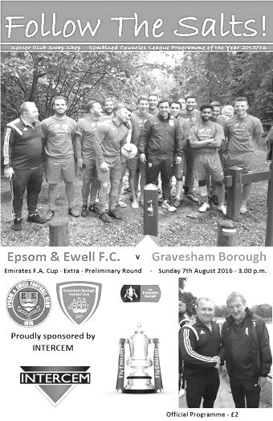
The F.A. Cup has not been kind to us in recent years. Defeats to Whyteleafe, Croydon and Erith & Belvedere, all at High Road mean that our last home win in the competition was back in 2012 against Ryman League Three Bridges. Following today's win we now get another crack at a Ryman League team when we travel to Faversham Town in the next round.

But it so nearly went wrong as Gravesham Borough, playing a division below us in the Southern Counties League East Division One, started well and would not give up, even when reduced to ten men midway through the second half.

We made just one change to the line-up with Tom Neale coming in for Jack Watret and after the scoring heroics on Tuesday it would have been very easy to think that we could be comfortable winners here, but any complacent thoughts were removed with just two minutes and fifteen seconds on the clock when a long throw in sailed over everyone and was headed in by the unmarked Charlie Plummer from close range. A disappointing goal to concede to say the least.

Bearing in mind our horror start in last season's competition when Erith & Belvedere had scored after just 19 seconds, there were no doubt some concerns in the thoughts of supporters. To their credit our players fought back immediately and Matt Farrell glanced a header wide from a dangerous Rob Hendry left wing cross when it required a fuller contact. In the ninth minute another Hendry cross was met by a Daryl Cooper-Smith header at the far post which thumped against the crossbar and away to safety.

An early injury to the visitors Dave Ayeni didn't appear to affect them and they went close with a hooked effort over Michael Eacott's cross bar from ten yards but then Tom Neale went close with a long range strike before forcing a save from visiting keeper Ashley Davy moments later. However, the contact wasn't the greatest and he was able to keep the ball out. Craig Hastings was next to get close to the target as a deep Elliott Thompson corner was met by a looping header that dropped inches over the bar and onto the back stanchion of the goal.

There was a slightly contentious incident in the 39th minute when Hendry was running at goal before being brought down on the edge of the box. However, the referee had been slightly distracted by shouts for a head injury to a visiting player and had just looked away at the split second the foul occurred. In the end the game was stopped for the injury and the chance was gone. But not for long. Just a minute later we attacked on the right and James

Taylor, marking his 100th appearance for the club, sent over a pinpoint cross from out deep and Cooper-Smith sent his header back across the keeper giving him no chance.

The second half started in a scrappy manner with a yellow card for Neale and for Gravesham's Mark Wallis. From this point though, we started to assert a bit of control and in quick succession Hendry and Farrell were just wide with powerful efforts before Plummer was booked for a challenge on Tom Neale. Pressure was building though and a double substitution helped to take our performance to a higher level as Matt Ferdinando and Sam Robinson joined the fray after 65 minutes.

Within seconds a ball was put through to Neale who was through on goal but his effort was blocked by Davy before Cooper-Smith lashed the loose ball goalwards. It was on target and was beating the keeper too but was deflected wide by a defender. Surely the pressure would count for something. In the 68th minute it did, as Ferdinando was set off down the right. He cut in along the touch line and laid the ball back for Neale to guide his shot into the top corner from ten yards out to give us our first lead of the day. After 75 minutes the match looked over as Marcus Heddon, playing as an emergency full back after an injury to their long throw specialist Oscar Saxton, was sent off for a two footed challenge on Neale.

Robinson hit the bar with a free kick, with Davy getting a slight touch before Griffin shot wide after more good work from Ferdinando. However, we hadn't finished them off yet and after Robinson stumbled they had a good opportunity to score but the attempt was deflected wide for a corner. This enabled the big lads to get forward but in the process we didn't stop Mark Wallis from getting to the deep corner first to knock in an equaliser in the 85th minute. All of a sudden it looked as though we were headed to Chatham Town for a replay, but fortunately we are a resilient bunch and were able to find yet another gear.

With time ticking away Neale got on the end of a ball through and shot wide in just getting to the ball ahead of the keeper who then caught him. The referee was clear, it was a penalty. Some would argue that as Neale had got his shot away anyway, maybe it shouldn't have been given and I have some sympathy with that view. However, Robinson stepped up to send Davy the wrong way from the spot in the 89th minute and we could breathe again. Three minutes later we wrapped up the win with a speculative 30 yard effort from Cooper-Smith that deceived the keeper and bounced past him into the net before he then made a good break on the right before squaring the ball to the recently introduced substitute Jordan Gallagher and the youngster on his debut found his tap in blocked but recovered to reach the loose ball first and knocked it into the empty net in the fifth minute of injury time to give the scoreline a flattering look.

So it all turned out well in the end and we have now scored 14 goals in our first two matches of the season. On a hot day, it's hard to argue with this as the work rate was excellent in a competitive and combative contest against a team that will surely do well this season, but there are still areas of concern and fortunately with no replay required we now have six clear days to work on them before making a League trip to Windsor; one of only three venues where we lost a match last year.

Epsom and Ewell: Michael Eacott, James Taylor, Matt Tanton. Dan Dean (c), Craig Hastings, Elliott Thompson, Rob Hendry, Matt Farrell, Tom Neale, Daryl Cooper-Smith, Reisse Griffin

Subs: Matt Ferdinando for Hendry (65), Sam Robinson for Thompson (65), Jordan Gallagher for Griffin (89)

From behind the goal
Windsor 2-1 Epsom & Ewell
Combined Counties League - Saturday 13th August 2016

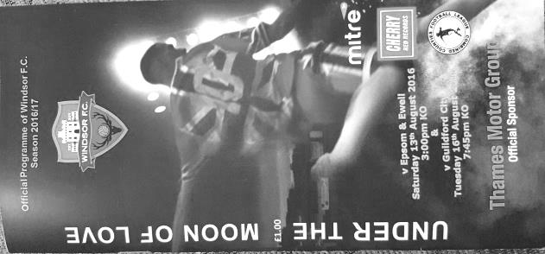
Stags end another successful Salts run with cruel late winner

Back in 2012/13 our club record run of 12 wins was ended when Windsor defeated us 3-1 at High Road. This time we went into our meeting on the back of another club record with eight straight away wins but again had to suffer defeat at their hands, this time by a score of 2-1. It was in fact our first defeat away from home since 23rd January, when we lost our League game at, yes, Stag Meadow and in almost identical circumstances, as once again we led early but fell away to concede twice.

We made three changes from the win over Gravesham Borough with Sam Robinson and Matt Ferdinando coming into midfield for Reisse Griffin and Tom Neale as Glyn rotated the squad a little, with one eye maybe on the upcoming matches with CB Hounslow United and Faversham Town. The final change came as a result of Captain Dan Dean's absence on holiday, so Alex McKay slotted straight in alongside Craig Hastings with Matt Farrell claiming the Captain's armband.

Right from the start this match was very even. A couple of half chances came and went for each team before an under hit back pass enabled Daryl Cooper-Smith to reach the ball, round the keeper and slot the ball into the empty net to give us a gift lead in the 18th minute. The hosts responded well, going up the hill and Michael Eacott was forced into a good save after he had failed to hold a deep free kick in the first instance.

However, they kept going and Keiran Knight turned Hastings about 25 yards out, took a couple of steps and fired the ball low past Eacott from the edge of the box for an excellent finish in the 28th minute. We couldn't complain as the two sides looked extremely well matched and they deserved to be level. We nearly scored just before the break when a Ferdinando shot was fumbled by the home keeper, under pressure from McKay but the ball never fell for us and was cleared, so we went into the break at 1-1.

The second half started with a scare when a Windsor left winger appeared to get around McKay before crumpling to the ground in the penalty area but the referee

wasn't convinced and this was followed by an injury to Ferdinando after he received a solid but fair challenge and Griffin came on in his place, almost scoring with his first touch but his twenty yard left footed attempt was just high and wide of the goal. With Neale on for Rob Hendry shortly afterwards we had to use a third substitute just moments later after Elliott Thompson injured his ankle.

The game took a turn for the worse in the 72nd minute when Sam Robinson showed great skill to beat his opponent and then get a pass away before being felled by a horrible tackle from the incoming Baboucarr Jarra. It was high, late, reckless, designed to take the opponent out and was also straight in front of the referee, but he then inexplicably felt the need to wander forty yards across the pitch to speak with his Assistant before issuing just a yellow card. In these days of players and clubs having to respect the officials, the least they can do in return is protect our players while they are out there as we picked up half a dozen red cards last season for far less than that.

But the match remained eleven against eleven and we pushed for a winner. Robinson had fortunately recovered after treatment and put in a dangerous free kick that nearly fell for Hastings before the ball was cleared for a corner and from that set piece McKay met Robinson's delivery with a downward header but it bounced straight up into the keeper's arms. After 80 minutes a great crossfield ball found Griffin in space and his pass back in was controlled and finished off by Neale but he had moved early and the Assistant's flag denied him a potential winner. Regrettably this offside would cost us as we were stretched in injury time and as the ball came in from the Windsor right wing it was knocked in from close range by the unmarked Keanu Williams a minute into injury time for their winner.

On another day we might well have pinched this match but over the ninety minutes we just didn't do enough to win the match. Despite this, the defeat was also undeserved as these were two well matched teams and arguably we should have had a man advantage for almost the final 25 minutes after all the injury time was added in, but the fact remains that we have conceded two goals in all three of our competitive outings so far and if we are to keep pace with the new leaders Hartley Wintney this season we cannot afford to keep doing this.

Epsom and Ewell: Michael Eacott, James Taylor, Matt Tanton. Alex McKay, Craig Hastings, Elliott Thompson, Rob Hendry, Matt Farrell (c), Daryl Cooper-Smith, Sam Robinson, Matt Ferdinando

Subs: Reisse Griffin for Ferdinando (54), Tom Neale for Hendry (64), Jordan Gallagher for Thompson (70)

EL Records Premier Challenge Cup
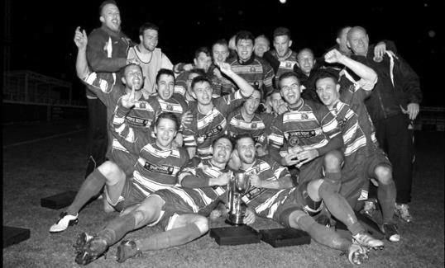
First Round
Redhill | 6/9 | Bedfont & Feltham
Spelthorne Sports | 13/9 | Sutton Common Rovers
Knaphill | 9/9 | Camberley Town
Worcester Park | 24/9 | Dorking
Epsom & Ewell | 6/9 | Abbey Rangers
Westfield | 6/9 | North Greenford United
Cobham | 6/9 | Bagshot
CB Hounslow United | 6/9 | Farnham Town
South Park Reserves | 14/9 | Balham
Second Round
Hanworth Villa | 4/10 | 5
AFC Hayes | 4/10 | 9
Epsom Athletic | 28/9 | Windsor
2 | V | Bedfont Sports
Raynes Park Vale | 4/10 | Colliers Wood United
Frimley Green | 4/10 | Banstead Athletic
6 | 4/10 | 1
Staines Lammas | 15/10 | 8
4 | V | Cove
Badshot Lea | 4/10 | Guildford City
Chertsey Town | 4/10 | 3
7 | V | Chessington & Hook United
Hartley Wintney | 4/10 | AC London
Horley Town | 4/10 | Sheerwater
Walton & Hersham | 4/10 | Eversley & California
Ash United | 11/10 | Farleigh Rovers

Surrey Senior Cup
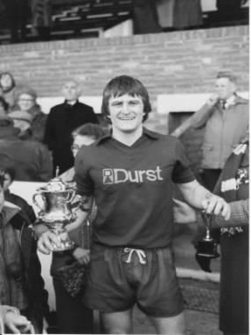
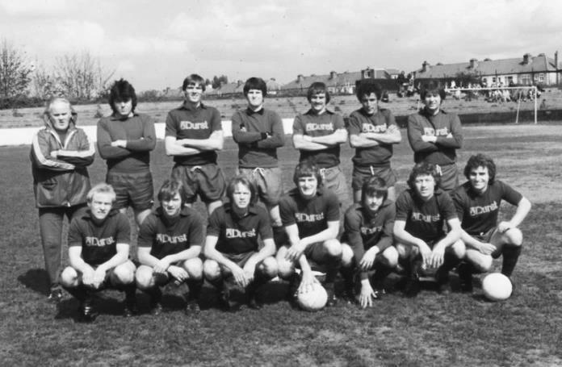
First Round
Abbey Rangers | V | AFC Croydon Athletic
Whyteleafe | V | Westfield
Second Round
Kingstonian | V | Met Police
Ashford Town (Mx) | V | Knaphill
Woking | V | Walton Casuals
2 | V | Colliers Wood United
Guildford City | V | Horley Town
Egham Town | V | Corinthian Casuals
Godalming Town | V | Merstham
Molesey | V | Leatherhead
Raynes Park Vale | V | Sutton United
Sutton Common Rovers | V | Camberley Town
Dorking Wanderers | V | South Park
Badshot Lea | V | Farnham Town
Walton & Hersham | V | Croydon
Carshalton Athletic | V | Tooting & Mitcham United
Chertsey Town | V | 1
Epsom & Ewell | v | Chipstead

Centre page for results

Centre page for results

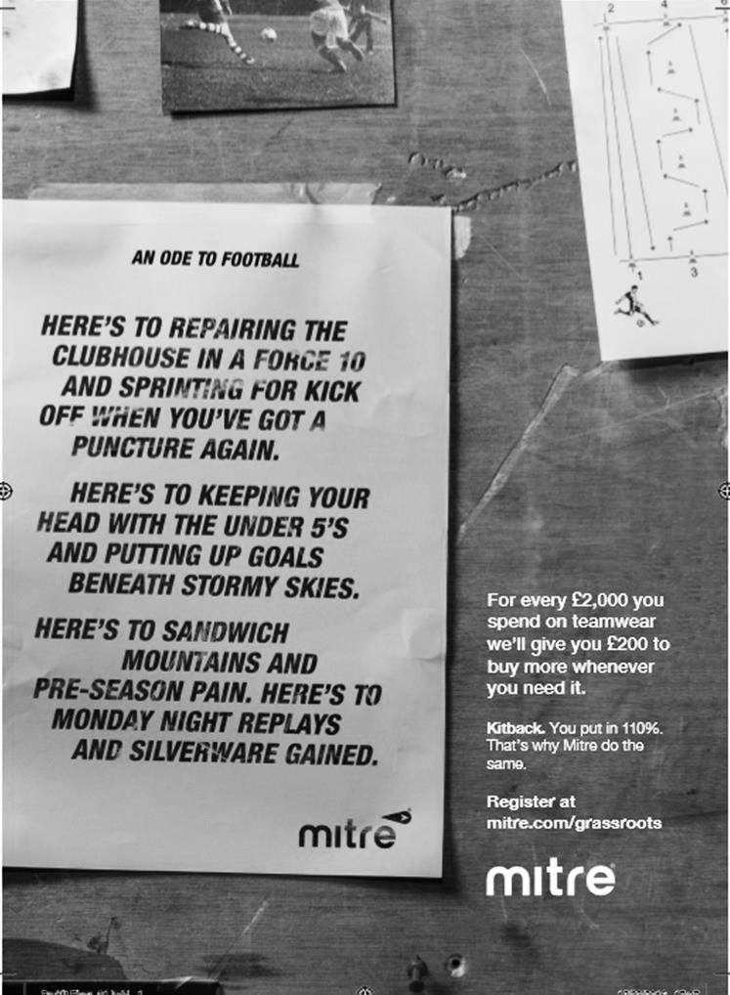

CB Hounslow United – History
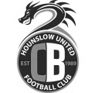
CB Hounslow United F.C is a Football club based in the London Borough of Hounslow. The team was originally called Richmond Rangers, and was a collection of friends and local troubled youth. In season 1987/88 it was disbanded and reformed in 1988/89 under the new name.

CB stands for ‘Cater Bank’ which was the company co-owned by the late father of our current chairman Frank James. CB Hounslow played in the Hounslow & District Football League with some distinction, and after 5 fairly successful years we were promoted to the Middlesex county Football League (MCFL) in 1994/95.

We then took our present name CB Hounslow United. CB Hounslow United played for 11 years in the MCFL before being promoted to the Combined Counties in 2005. The club is now affiliated to the Combined Counties League, Middlesex County FL, West Middlesex Sunday League, Allied Counties Youth League, Surrey Youth League, West Middlesex Youth League and Harrow Youth League.

The club this season will be competing in The FA Cup, The FA Vase, The FA Youth Cup and The Help for Heroes Senior Cup amongst many other Cups.

The 1st Team & U18’s find themselves still ground Sharing with our local rivals and good Friends at Bedfont & Feltham FC at The Orchard, Hatton Road, Bedfont, whilst we await the Completion of our new ground at Green Lane, Hounslow.

As always I would like to thank our numerous sponsors, who donate to the youth teams and the main body of the club and also help greatly with the fund raising for the build of the new ground. The club continues to grow its partnership with London Borough of Hounslow Council. Finally, we have over 50 volunteers who make up our management, coaching and secretarial staff who without them the club wouldn’t be where it is now.

Congratulations JT!
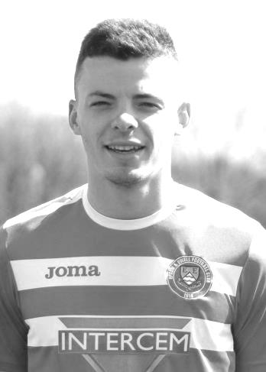
Against Gravesham Borough on Sunday 7th August James Taylor became the 116th player in club history to make 100 appearances for Epsom & Ewell.

James has been with us for nearly three seasons now, since making his debut on 26th August in our 2-0 home League win over Croydon. During that time he has proven to be equally capable at centre-half and at right back, and also produced an excellent cross for Daryl Cooper-Smith to equalise in his 100th match.

His first season was interupted by travel issues as he regularly travelled to and from University at Eastbourne and I am sure, originally intended to play as a central defender, but once Captain Sam Currie injured his knee at the start of 2014/15 he filled in at right back for most of the season and he now has that opportunity once again.

Some of you won’t be aware that James’ father Dave also played for us, recording over 50 appearances for us in the Isthmian League Premier Division back in 1985/86 and still regularly attends to watch his son. Hopefully he will be doing this for a while yet. Congratulations JT!

Scouting the Opponent – Faversham Town
We visit Faversham Town at Salters Lane on Saturday hoping to keep our F.A. Cup run alive.

But it won’t be easy. Faversham have been at the business end of the Ryman League South Division for a while now and have come a long way since reforming a few years ago. Salters Lane lay derelict for a couple of seasons after folding mid-season during 2003 but rejoined the Kent County League in 2005, winning it immediately and followed it up with the Kent League title four years later.

Our two clubs have met before in the Athenian League during 1975/76. We were on our way up the Leagues, while Faversham were about to return to the Kent League and we defeated them home and away; 3-0 at West Street with goals from Barry Denman, former Assistant Manager Tony Coombe and an own goal and then 2-0 in Kent on 10th January 1976 with Tommy Tuite and a Dave Ritman penalty securing the victory.

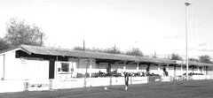
The main stand at Salters Lane, unchanged from the old days.

Ryman League Division One South Final Table – 2015/16
 | P | W | D | L | F | A | Pts | GD
Folkestone Invicta | 46 | 36 | 6 | 4 | 102 | 34 | 114 | +68
Dorking Wanderers | 46 | 27 | 9 | 10 | 99 | 56 | 90 | +43
Worthing | 46 | 27 | 7 | 12 | 96 | 56 | 88 | +40
Hythe Town | 46 | 27 | 6 | 13 | 74 | 49 | 87 | +25
Faversham Town | 46 | 25 | 8 | 13 | 76 | 45 | 83 | +31
Corinthian-Casuals (-3) | 46 | 26 | 7 | 13 | 75 | 52 | 82 | +23
Hastings United | 46 | 25 | 6 | 15 | 99 | 64 | 81 | +35
Herne Bay | 46 | 22 | 10 | 14 | 79 | 54 | 76 | +25
Molesey | 46 | 23 | 6 | 17 | 87 | 83 | 75 | +4
Carshalton Athletic | 46 | 21 | 9 | 16 | 83 | 74 | 72 | +9
South Park | 46 | 21 | 9 | 16 | 78 | 71 | 72 | +7
Ramsgate | 46 | 21 | 8 | 17 | 92 | 76 | 71 | +16
Guernsey | 46 | 21 | 5 | 20 | 94 | 88 | 68 | +6
Three Bridges | 46 | 20 | 6 | 20 | 59 | 67 | 66 | -8
Whyteleafe | 46 | 19 | 5 | 22 | 69 | 77 | 62 | -8
Walton Casuals | 46 | 18 | 6 | 22 | 74 | 85 | 60 | -11
Tooting & Mitcham United | 46 | 16 | 10 | 20 | 66 | 71 | 58 | -5
Sittingbourne | 46 | 16 | 6 | 24 | 63 | 77 | 54 | -14
Chatham Town | 46 | 13 | 7 | 26 | 61 | 70 | 46 | -9
East Grinstead Town | 46 | 12 | 7 | 27 | 55 | 84 | 43 | -29
Chipstead | 46 | 11 | 6 | 29 | 54 | 92 | 39 | -38
Walton & Hersham (-3) | 46 | 9 | 6 | 31 | 50 | 113 | 30 | -63
Whitstable Town | 46 | 8 | 2 | 36 | 52 | 118 | 26 | -66
Peacehaven & Telscombe | 46 | 6 | 7 | 33 | 48 | 129 | 25 | -81

Combined Counties League Premier Division Opponents
All-time Records
inc Saturday 13th August | P | W | D | L | F | A | PPG | GD | Best  Win | Worst  Loss
Bedfont & Feltham | 1 | 1 | 0 | 0 | 9 | 2 | 3.00 | +7 | 9-2 | X
Spelthorne Sports* | 5 | 4 | 1 | 0 | 15 | 6 | 2.60 | +9 | 6-2 | X
Sutton Common Rovers | 10 | 8 | 1 | 1 | 27 | 12 | 2.50 | +15 | 4-0 | 1-4
Horley Town | 28 | 19 | 5 | 4 | 62 | 30 | 2.21 | +32 | 6-0 | 1-3
Colliers Wood United | 21 | 14 | 2 | 5 | 45 | 28 | 2.10 | +17 | 4-0 | 0-3
Westfield | 18 | 11 | 3 | 4 | 39 | 29 | 2.00 | +10 | 6-1 | 0-4
Bedfont Sports | 9 | 5 | 2 | 2 | 13 | 10 | 1.89 | +3 | 3-0 | 0-4
Farnham Town | 13 | 7 | 2 | 4 | 23 | 22 | 1.77 | +1 | 3-1 | 1-4
Guildford City | 16 | 9 | 1 | 6 | 32 | 22 | 1.75 | +10 | 5-1 | 1-5
Hanworth Villa | 14 | 7 | 3 | 4 | 34 | 24 | 1.71 | +10 | 5-0 | 1-4
Raynes Park Vale | 26 | 13 | 5 | 8 | 57 | 36 | 1.69 | +21 | 6-1 | 0-2
Knaphill | 6 | 3 | 1 | 2 | 11 | 8 | 1.67 | +3 | 4-1 | 1-2
Walton & Hersham | 49 | 24 | 9 | 16 | 100 | 96 | 1.65 | +4 | 6-0 | 0-8
Camberley Town* | 88 | 38 | 21 | 28 | 158 | 123 | 1.54 | +35 | 9-1 | 0-4
Hartley Wintney | 10 | 4 | 3 | 3 | 25 | 17 | 1.50 | +8 | 5-0 | 2-4
Badshot Lea | 17 | 7 | 3 | 7 | 31 | 33 | 1.41 | -2 | 4-1 | 0-4
Windsor | 48 | 18 | 12 | 18 | 88 | 90 | 1.38 | -2 | 4-0 | 0-6
Chertsey Town | 47 | 17 | 5 | 25 | 70 | 86 | 1.19 | -16 | 3-0 | 0-7
AFC Hayes | 8 | 2 | 2 | 4 | 16 | 15 | 1.00 | +1 | 7-0 | 0-3
Abbey Rangers | 0 | 0 | 0 | 0 | 0 | 0 | 0.00 | 0 | X | X
CB Hounslow United | 1 | 0 | 0 | 1 | 1 | 2 | 0.00 | -1 | X | 1-2
Total* | 435 | 211 | 81 | 142 | 856 | 691 | 1.65 | +165 | - | -
* includes one abandoned match v Camberley and one loss on penalties v Spelthorne

CCL Premier Division Club Directory
ABBEY RANGERS Telephone: 01932-422962 - Ground: Addlestone Moor, Addlestone, Surrey KT15 2QH - Colours: Black & White Stripes/Black/Black

A.F.C. HAYES Telephone: 0208-845-0110 - Ground: Farm Park, Kingshill Avenue, Hayes, Middx. UB4 8DD - Colours: Blue and White Stripes/Blue/Blue

BADSHOT LEA Telephone: 01252-320385 - Ground: Ash United FC, Shawfield Stadium, Youngs Drive, Shawfields Road, Ash, Hampshire. GU12 6RE - Colours: Claret/White/Claret

BEDFONT & FELTHAM Telephone: 0208 890 7264 - Ground: The Orchard, Hatton Road, Bedfont, Middx TW14 9QT - Colours: Yellow & Blue/Blue/Blue

BEDFONT SPORTS Telephone: 0208-831-9067 - Ground: Bedfont Sports Club, Hatton Road, Bedfont, Middx TW14 8JA - Colours: Red & Black Hoops/Black/Red & Black Hoops

CAMBERLEY TOWN Telephone: 01276-65392 - Ground: Krooner Park, Wilton Road, Camberley, Surrey. GU15 2QW - Colours: Red & White Stripes/Blue/Red

CB HOUNSLOW UNITED Telephone: 0208 890 7264 - Ground: The Orchard, Hatton Road, Bedfont, Middx TW14 9QT - Colours: Green/Black/Green

CHERTSEY TOWN Telephone: 01932-561774 - Ground: Alwyns Lane, Chertsey, Surrey. KT16 9DW - Colours: Royal Blue & White Stripes/Royal Blue/Royal Blue

COLLIERS WOOD UNITED Telephone: 0208-942 8062 - Ground: Wibbandune Sports Ground, Robin Hood Way, Wimbledon. SW20 0AA - Colours: Blue & Black Stripes/Black/Black
EPSOM & EWELL Telephone: 01737-553250 - Ground: Chipstead FC, High Road, Chipstead, Surrey. CR5 3SF - Colours: Royal Blue & White Hoops/Royal Blue/Royal Blue

FARNHAM TOWN Telephone: 01252-715305 Ground: Memorial Ground, Babbs Mead, West Street, Farnham, Surrey. GU9 7DY Colours: - Claret & Sky Blue /White/ Claret & Sky Blue

GUILDFORD CITY Telephone: 01483-443322 - Ground: The Spectrum, Parkway, Guildford, Surrey. GU1 1UP - Colours: Red & White Stripes/Black/Black

HANWORTH VILLA Telephone: 0208-831-9391 - Ground: Rectory Meadows, Park Road, off Hounslow Road, Hanworth, Middlesex. TW13 6PN - Colours: Red & White Stripes/Black/Black

HARTLEY WINTNEY Telephone: 01252-843586 - Ground: Memorial Playing Fields, Green Lane, Hartley Wintney, Hants RG27 8DL - Colours: Orange & Black/ Orange /Orange

HORLEY TOWN Telephone: 01293-822000 - Ground: The New Defence, Anderson Way, Court Lodge Road, Horley, Surrey. RH6 8SP - Colours: Claret & Sky Blue/Claret/Claret

KNAPHILL Telephone: 01483-475150 - Ground: Brookwood Country Park, Redding Way, Lower Guildford Road, Knaphill, Surrey. GU21 2AY - Colours: Red/Black/Red

NORTH GREENFORD UNITED Telephone: 0208 422 8923 - Ground: Berkeley Fields, Berkeley Avenue, Greenford, Middx UB6 0NX - Colours: Royal Blue & White/Royal Blue/Royal Blue

SUTTON COMMON ROVERS Telephone: 01932-866386 - Ground: Sutton United FC, Gander Green Lane, Sutton, Surrey SM1 2EY - Colours: Yellow/Black/Black

RAYNES PARK VALE Telephone: 020-8540-8843 - Ground: Prince Georges Playing Field, Grand Drive, Raynes Park, London. SW20 9NB - Colours: Blue/Blue/Red

SPELTHORNE SPORTS Telephone: 01932-961055 - Ground: Spelthorne Sports Club, Staines Road, Ashford Common, Ashford, Middx. TW15 1RY - Colours: Light & Dark Blue/Dark Blue/Light Blue

WALTON & HERSHAM Telephone: 01932 245263 - Ground: Stompond Lane, Walton on Thames, Surrey KT12 1HF - Colours: Red/Red/Red

WESTFIELD Telephone: 01483-771106 - Ground: Woking Park, Kingfield Road, Woking, Surrey. GU22 9BA - Colours: Yellow/Black/Black

WINDSOR Telephone: 01753-860656 - Ground: Stag Meadow, St Leonards Road, Windsor, Berks SL4 3DR - Colours: Red/Red/Red

Every Opponent A-Z
Over the years we have played many, many different opponents. Exactly how many is a difficult question, as it all depends on your definition. Are Camberley & Yorktown different to Camberley Town, or are Epsom Town different to Epsom F.C. or Epsom & Ewell F.C.?

In my analysis I have classed them as the same team, and will work through them all from A to Z. Some we have played many times, whilst others we have met just once or twice. Enjoy!

Spelthorne Sports: Played 5 - W4 D1 L0 - F15 A6 - PPG - 2.60 - Fantastic

Spelthorne Sports are one of our newer opponents, having met for the first time in 2013/14 during their amazing promotion season in which they were unbeaten in all competitions until the first week of May when they lost a couple of Cup finals.

To get to one of those finals they defeated us in the Southern Combination Cup on Thursday evening, 24th April 2014. The result doesn’t go down as a loss in my records as the match was drawn 0-0 after extra time, but they were the ones to progress 4-2 on penalties.

Since then we have met four times in the League and have won all four encounters. The first was arguably the most impressive of these as we visited on 27th September 2014 and won 3-0 to hand them their first home defeat in 18 months with Dale Marvell scoring on his 300th appearance.

The return match was a cracker as we led 2-0 but then had Alex McGregor sent off. Immediately the deficit was reduced to 2-1 before Matt Ferdinando scored a fantastic solo goal with a great finish from distance to restore the two goal lead. However, they weren’t fininshed and pulled it back to 3-3 with five minutes remaining before Ferdi stepped up again to secure a dramatic late winner by blocking an attempted defensive clearance into the net for a 4-3 win!

Last season’s wins were equally impressive as we registered a 6-2 win over there before a Ferdinando free kick secured a 2-1 victory here in March 2016.

Although we currently have a good record against them, they still registered two top-ten finishes in their opening seasons and as their ground develops and improves, the potential for further progress remains.

St Albans City: Played 12 - W5 D2 L5 - F19 A18 - PPG - 1.42 - Average

The famous St Albans City club were Isthmian League giants for over fifty years before we first met. We first competed against each other in the 1978/79 season, by which time we were both Isthmian League Division One clubs, although ironically the meeting was in the London Senior Cup on Tuesday 17th October 1978 when second half goals from Tommy McCready and Jeff Hunn gave us a 2-1 win on our first visit to Clarence Park.

Three weeks later we defeated them 4-0 at West Street in our first League meeting but were held 2-2 in March 1979 when visiting Hertfordshire for our return League match.

We were back there in the September for another League match, although this time we were on the receiving end of a 4-0 thrashing. We won the return match at West Street by two clear goals as both teams finished in mid-table. In 1980/81 we lost 2-1 over there and were only able to draw 0-0 at home.

My first memories of St Albans City came in the 1981/82 season. Both meetings came after the Pat O’Connell walkout. Our trip there was on Saturday 3rd April and we all congregated at West Street to get on a coach that never came. When we realised, a few of us decided to travel there by train instead and it was well worth it as we won 2-1. I recall Malcolm Spratt’s winning header from a

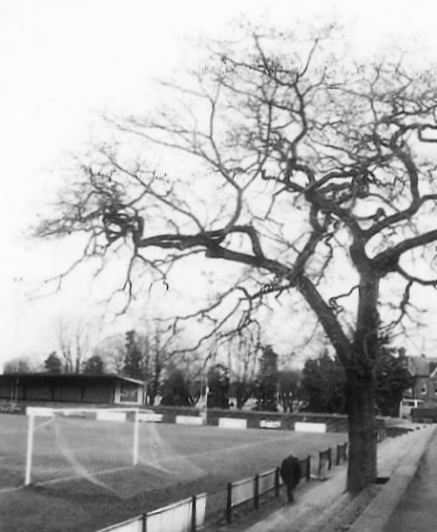
right wing cross as we were stood at the bottom end of the ground, right next to their famous tree that for those who didn’t see it was situated right in the middle of their terracing!

However, just three weeks later they had their revenge with their first ever win at West Street, repeating the 2-1 score line.

1982/83 was to be a bad season for the Saints. Only one team was relegated from Division One that season as we only had 21 teams, but they were the ones who fell, despite beating us 1-0 at Clarence Park on 4th December 1982. I remember the goal came in the second half immediately after Steve Hill had been one on one with the keeper who made an important save. Two weeks later though we received our own Christmas present when battering them 5-0 at West Street, with Steve Hill taking personal revenge with four of the goals.

That was it for League action. The stay in Division Two was brief as they bounced back but we also went up that year and when we came back down in 1986 we switched places with them once more. Our final meeting came in the League Cup on 13th September 1988 when by then they were once again a Premier Division club and we were by then in Division Two South. Understandably they won easily by five clear goals.

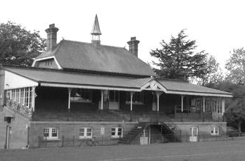
Since that time the Saints have had a good couple of decades. They nearly qualified for the National Conference in 1993 but were rejected because of their famous tree. Mysteriously the tree became diseased in 1998 and had to be removed, but with the “obstacle” to their progress no longer an issue they were able to move up but only spent a season with the elite and they currently play in the Conference South.

Above left: The famous tree “copyright Kerry Miller”

Left: The grand old St Albans City stand

Match and Ball Sponsorships – 2016/17
Opponent | Date | Match Sponsor | Ball Sponsor
Gravesham Borough | 07/08/16 | Club President - Stella Lamont
Gravesham Borough | 07/08/16 | Relocation Committee Member - Mike Lovett
CB Hounslow United | 16/08/16 | EEFC Management Committee
Abbey Rangers | 23/08/16 | Steve & Geoff Dyke
Horley Town (11.30am) | 29/08/16 | In Memory of Chris Henry
Abbey Rangers (LC) | 06/09/16
Camberley Town | 10/09/16
Knaphill | 24/09/16
Sutton Common Rovers | 08/11/15
Windsor | 15/11/16
Bedfont Sports | 19/11/16
AFC Hayes | 26/11/16
Hanworth Villa | 13/12/16
Chertsey Town | 17/12/16
Raynes Park Vale (11.30am) | 27/12/16
Spelthorne Sports | 07/01/17
Bedfont & Feltham | 21/01/17 | Programme Editor - Richard Lambert
Badshot Lea | 04/02/17
Westfield | 18/02/17
Walton & Hersham | 04/03/17
Hartley Wintney | 18/03/17
Farnham Town | 25/03/17
Colliers Wood United (1.00pm) | 14/04/17 | Good Friday match – make a note!
North Greenford United | 22/04/17
Guildford City | tba
 | tba | F.A. Vase – if drawn at home
Chipstead (SSC) | tba
For League, League Cup and Surrey Senior Cup Matches:
Match sponsorship - £40.00 Match ball sponsorship - £25.00. Combined £55.00.
For F.A. Cup and F.A. Vase matches:
Match sponsorship - £50.00 Match ball sponsorship - £30.00. Combined £65.00.

Sponsorship includes: (x2 for match, x3 for match and ball)

Admission, programmes, hospitality and advertising and mascot for the day (if required).
If you are interested, just speak to a Committee Member, or drop me an email at: richard.c.lambert@gmail.com

We also thank our Kit Sponsors INTERCEM

Salts Super Six Predictor
The Salts Super Six Predictor is live again for the first time this season. The tickets are on sale at today’s game to the left of the gate, and are for this evening’s matches in the newly named English Football League (the old Championship from last season).

The competition is easy to play and you don’t even have to be at the match! To win, you simply need to predict the results of six matches correctly from the three options, fill in the form and make sure it is back with one of our distributors before the deadline on the ticket. The latest fixtures are shown here.

If you are a club regular, you just need to place your name on the sheet, although if you aren’t, then we’ll need a contact number from you too. We will announce any winners on the website within three working days, so don’t worry, we won’t miss you!

We had a big jackpot winner last year and who knows how much could be won this time! It is currently £73 and you’ll always know the size of the pot before you enter.

Please note that if there is more than one winner, the prize pot would be shared between the winners. All you need to do now is have a go, as many times as you like!

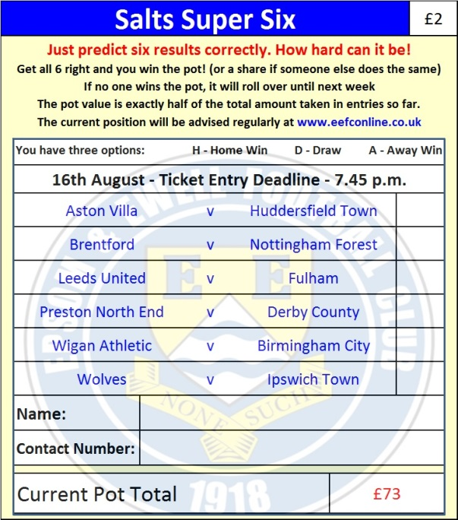

Good luck!

Combined Counties League – Premier Division
Tuesday, 16th August 2016 - Kick-off 7.45 p.m.
Epsom and Ewell  (Royal Blue & White hoops) | V |  | CB Hounslow United  (All Grey)
Squad | NUMBERS
Michael Eacott |  |  | Alex Wines
James Taylor |  |  | Tommy O’Neill
Matt Tanton |  |  | CJ Church
© Dan Dean |  |  | Jordan Ireland
Craig Hastings |  |  | Stuart Bamford
Elliott Thompson |  |  | Harry Driver ©
Rob Hendry |  |  | Ronnie Bangato
Matt Farrell |  |  | Gavin Bamford
Tom Neale |  |  | Nick Hardy
Daryl Cooper-Smith |  |  | Jack Watts
Reisse Griffin |  |  | Justin Thompson
Sam Currie |  |  | Stef Nor
Rhys North |  |  | Oliver Wright
Sam Robinson |  |  | Dunnel King
 |  |  | Dan Lucas
Matt Ferdinando |  |  | Simon Murr
Alistair Turpie |  |  | Lee Tunnel
Alex McKay |  |  | Harvey Lal
Savvas ‘Agi’ Panayiotou |  |  | Alvinio Pierre Louis
Savvas ‘Agi’ Panayiotou |  |  | Sammy Kanani
Glyn Mandeville | MANAGER |  | Barry Chapman
Matt Smith | ASSISTANT |  | Gavin Bamford
Steve Eacott / Alex McKay / Jimmy Hendry | COACHES / PHYSIO |  | Pete Morris
REFEREE: D.Hayes
ASSISTANTS: R.Van Niekerk, J.O’Malley
Today’s Match and Match Ball are sponsored by:
The Epsom & Ewell FC Management Committee

OUR NEXT VISITORS TO HIGH ROAD (subject to F.A. Cup replay)
Abbey Rangers
Combined Counties League – Premier Division
Tuesday 23rd August 2016

